For ODE $x^{2}f"+x=\left(x^{2}+1\right)e^{x}$, we have the extra conditions as $f\left(0\right)=1$ and $f\left(1\right)=e$

It’s easy to get that the exact solution is ${f\left(x\right)=e}^{x}$

First we solve for the spectral solution for expansion up to $x^{3}$

Based on recursion relationship, we have $D$ matrix for derivation recursion relationship and $X$ matrix for non-constant coefficients.

Thus the matrix realization for the ODE is

$${(DDXX+I)}^{T}a=b$$

Matrix $D$ truncated at $x^{3}$ is:

$$D=$$

0 0 0 0

1 0 0 0

0 3 0 0

1 0 5 0

Matrix $X$ truncated at $x^{3}$ is:

$$X=$$

0 1 0 0

1/3 0 2/3 0

0 2/5 0 3/5

0 0 3/7 0

Thus, $A={(DDXX+I)}^{T}=X^{T}X^{T}D^{T}D^{T}+I=$

1 0 1 0

0 1 0 9

0 0 3 0

0 0 0 7

The elements of column *b* are found from

$b_{n}=\frac{2n+1}{2}\int_{-1}^{1}{P_{n}\left(x\right)\left(x^{2}+1\right)e^{x}dx}$

$b_{n}$ for n=3 is:

1.614643504944718

1.777899426251808

1.330606497348779

0.548143758894128

Now we put in the auxiliary conditions $f\left(0\right)=a_{0}-\frac{1}{2}a_{2}=1, f\left(1\right)=a_{0}+a_{1}+a_{2}+a_{3}=e$ to replace the last two rows of $A$ with the equivalent restrictions on the coefficients:

$$A^{'}=$$

1 0 1 0

0 1 0 9

1 0 -1/2 0

1 1 1 1

$$b_{n}^{'}=$$

1.614643504944718

1.777899426251808

1.000000000000000

2.718281828459046

Solve $A^{'}a=b'$ for $a$, we get:

$$a_{n}=$$

1.204881168314906

1.019355685672142

0.409762336629812

0.084282637842185

So we can expand

$$f\left(x\right)=\sum_{n=0}^{3}{a_{n}P_{n}\left(x\right)}$$

$$=1.204881+ 1.019356 x + 0.204881\left(-1+ 3x^{2}\right)+ 0.042141\left(-3x + 5x^{3}\right)$$

$$=1+ 0.892932 x + 0.614644 x^{2} + 0.210707 x^{3}$$

Plot for $f\left(x\right)$:

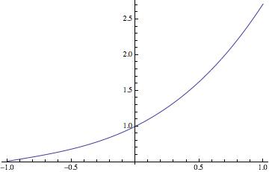

$$L2error=\sqrt{\int_{-1}^{1}{{(f\left(x\right)-e^{x})}^{2}dx}}=0.08749$$

Plot for ${L2error}^{2}$:

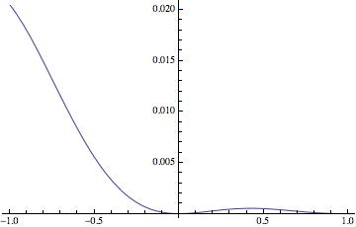

Secondly, we solve for the spectral solution for expansion up to $x^{5}$

Matrix $D$ truncated at $x^{5}$ is:

$$D=$$

0 0 0 0 0 0

1 0 0 0 0 0

0 3 0 0 0 0

1 0 5 0 0 0

0 3 0 7 0 0

1 0 5 0 9 0

Matrix $X$ truncated at $x^{5}$ is:

$$X=$$

0 1 0 0 0 0

1/3 0 2/3 0 0 0

0 2/5 0 3/5 0 0

0 0 3/7 0 4/7 0

0 0 0 4/9 0 5/9

0 0 0 0 5/11 0

Thus, $A={(DDXX+I)}^{T}=X^{T}X^{T}D^{T}D^{T}+I=$

1 0 1 0 8 0

0 1 0 9 0 36

0 0 3 0 25 0

0 0 0 7 0 49

0 0 0 0 13 0

0 0 0 0 0 21

The elements of column *b* are found from

$b_{n}=\frac{2n+1}{2}\int_{-1}^{1}{P_{n}\left(x\right)\left(x^{2}+1\right)e^{x}dx}$

$b_{n}$ for n=5 is:

1.614643504944718

1.777899426251808

1.330606497348779

0.548143758894128

0.137712471330815

0.019654844320030

Now we put in the auxiliary conditions $f\left(0\right)=a_{0}-\frac{1}{2}a_{2}+\frac{3}{8}a_{4}=1, f\left(1\right)=a_{0}+a_{1}+a_{2}+a_{3}+a_{4}+a_{5}=e$ to replace the last two rows of $A$ with the equivalent restrictions on the coefficients:

$$A^{'}=$$

1 0 1 0 8 0

0 1 0 9 0 36

0 0 3 0 25 0

0 0 0 7 0 49

1 0 -0.5 0 0.375 0

1 1 1 1 1 1

$$b_{n}^{'}=$$

1.614643504944718

1.777899426251808

1.330606497348779

0.548143758894128

1.000000000000000

2.718281828459046

Solve $A^{'}a=b'$ for $a$, we get:

$$a_{n}=$$

1.174571919929633

1.105197440811793

0.356937646586907

0.069995883419958

0.010391742303522

0.001187195407233

So we can expand

$$f\left(x\right)=\sum_{n=0}^{3}{a_{n}P_{n}\left(x\right)}$$

$$=1.174572 + 1.105197 x + 0.178469 (-1+ 3x^{2}) + 0.034998 (-3x + 5x^{3}) + 0.001299 (3- 30x^{2}+ 35x^{4}) + 0.000148 (15x - 70x^{3} + 63x^{5})$$

$=1+ 1.002430 x + 0.496437 x^{2} + 0.164601 x^{3} + 0.045464 x^{4} + 0.009349 x^{5}$

Plot for $f\left(x\right)$:

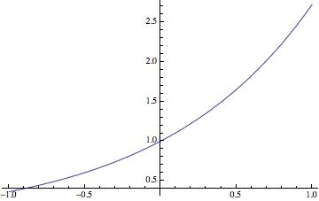

$$L2error=\sqrt{\int_{-1}^{1}{{(f\left(x\right)-e^{x})}^{2}dx}}=0.00168$$

Plot for ${L2error}^{2}$:

